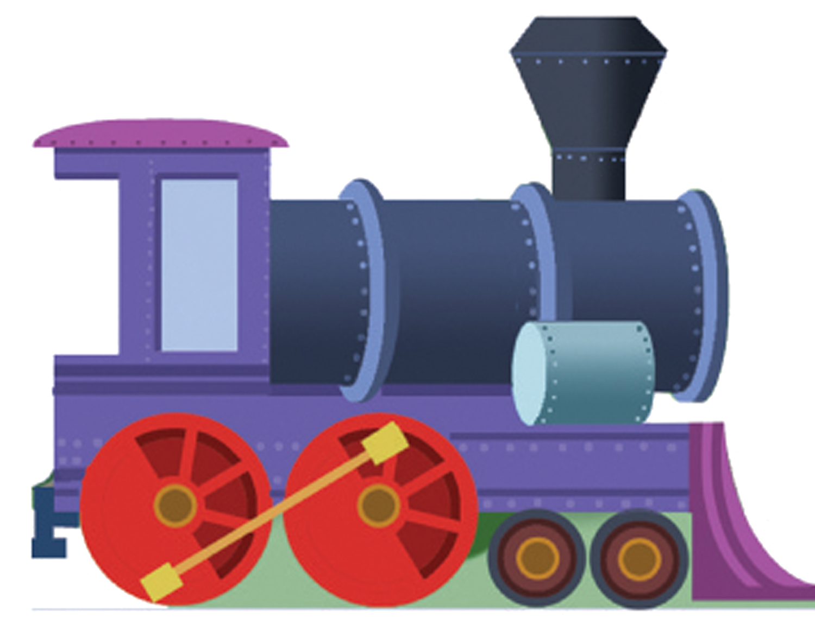
The Train Station Preschool
Authorization for Sunscreen

Child’s Name__________________________________________
Address_______________________________________________ Phone_________________________________________________

- The named student must apply________________________
(Name of sunscreen)

- Time/Frequency____________________________________

- To begin on _______________To end on________________

I, the parent of the above named student, request that The Train Station personnel supervise the administration of this medication, following the physician’s directions. I assume full responsibility and hereby release The Train Station Preschool and all school personnel from all liability in connection with this request.

______________________ _____________________________ Date Parent signature

Note: Sunscreen sent to school must be labeled with child’s name. Any child who does not have sunscreen will not be permitted to go outside and play.

